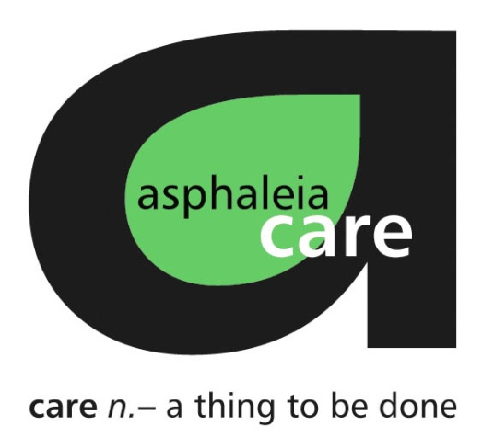

job description and person specification

Job title: Young People’s Advocate
Responsible to: Senior Advocate
Location: Home based with travel within East Sussex
Salary range: £10.50 per hour
Contract: Bank
Hours: Various as agreed. There is no guarantee of any number of hours being offered, any required hours would be discussed and agreed in advance.
about asphaleia

asphaleia started with four staff all sharing a passion for meeting the needs of children and young people and a willingness to take a risk!

From those beginnings, asphaleia now comprises a limited company and a registered international charity. These operate as four ventures. We use the word venture because it carries the sense of adventure that has led us on our unique and fascinating journey. The three different ventures sitting within the company are; care, fostering and training. asphaleia action, our charity has been pioneering new projects to meet ever increasing needs of young people both in the UK and internationally for almost 20 years.

our mission

The asphaleia mission is simple – to impact as many lives of children and young people who have experienced disadvantage as we can. We believe it is a simple, but very powerful mission that drives forward every aspect of our delivery and ensures we place children and young people at the heart of everything we do.

our values

Our values are summed up by three simple principles and these, when in action, create the asphaleia way of doing things.
- When working with children and young people, other professionals or colleagues we believe service and co-operation can only begin to be achieved to a high standard by considering the world of others.
- However, we believe it is not enough to solely believe the world of others matters – this is only a starting place. The asphaleia group believe in demonstrating our value of those we deliver services to, those who pay for our services and those we work with in every possible way.
- Finally, we believe we should aim to do everything well. We realise excellence is a journey and not a finitely achievable thing. Therefore even when we have done something well we should then aim to do it even better!

what we can offer you

- We are proud to be an Investor in People.
- We are committed to ongoing personal development for all staff.
- Joining a pension scheme.
- Cycle-to-work scheme.
- We have a social committee led by staff who organise socials for all asphaleia employees.

about asphaleia care
Providing high quality accommodation, outreach and support services for young people living across Sussex, London and Kent, asphaleia care is the longest running venture at asphaleia.

The team supports professionals working with young people aged 16-24, focusing on their wellbeing, welfare and skills development to aid successful transition into adulthood and independent living. We also offer Independent Visitor Services and Specialist Services, including CSE (child sexual exploitation) and particular expertise with UASC (unaccompanied asylum seeking children).

We are committed to making a positive difference to young people who are facing a period of change, uncertainty or are in need of support from a significant adult.

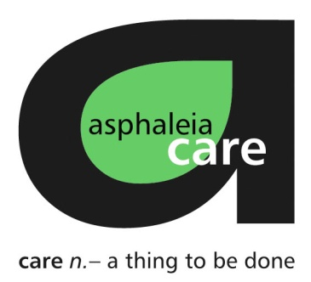
about the role

Key Responsibilities | As a Young People’s Advocate your role will be provide advocacy support to children and young people Looked After by East Sussex County Council Children’s Services, through individual community advocacy. Advocates support a range of children, including: children and young people with a Child Protection/Children in Need plan and post adoption children and young people.  Main responsibilities will include:  - Listening and supporting young people to express their wishes and feelings  - Ensuring the young people understands their rights  - Enabling young people to communicate their views and wishes and to seek a satisfactory resolution to any issues they raise.  - Supporting young people to self-advocate or represent their wishes and  feelings on their behalf when required.  - To support young people to access legal and other specialist support where required.  - Listening and supporting young people to express their wishes and feelings
Person Specification
Qualifications & Experience | - Educated to Level 3 qualification or equivalent, ideally in a relevant subject e.g. youth work, education or community work.  - Direct experience of working with young people who are Looked After.  - Experience of working within a children and families social care setting (such as a charity or local authority children's services).
Skills and knowledge | - Excellent written and spoken communication skills e.g. the ability to adapt communication according to setting or person.  - Energetic approach to work  - Knowledge of children’s legal rights  - Knowledge and experience of working with young people from diverse background and with various needs  - Quality, professional standards expected e.g. knowledge of National Advocacy Standards 2002 and The Advocacy Services and Representations Procedure (Children) (Amendment) Regulations 2004, Providing Effective Advocacy Services for Children and Young People Making a Complaint: ’Get it Sorted’ 2004  Quality and Professional standards  - Practice evident and knowledge of:  - National Advocacy Standards 2002  - The Advocacy Services and Representations Procedure Regulations 2004

safeguarding

asphaleia are committed to safeguarding and safer working practices. All successful applicants will be recruited according to safer recruitment practices and will undergo an enhanced DBS and other vetting checks.

Closing date:
How to apply:
Interview date:

